Lab

Nikita Dhingra

# Table of Contents

Table of Contents 2

Lab 2 3

Pre-requisites of Hadoop Installation and Configuration files for single node architecture 3

Screenshots 4

References 16

# Lab 2

## Pre-requisites of Hadoop Installation and Configuration files for single node architecture

The Apache Hadoop software library is a framework that provides simpler programming models for distributed processing of big data sets across clusters of machines. Each machine delivers local computing and storage, and it is capable of scaling up from a few servers to thousands of them. [1] Following are the common pre-requisites for the installation and configuration of Hadoop for the single node architecture:

**Operating System**:

Operating systems including Linux, macOS, and Windows are all compatible with Hadoop. However, it is usually used by Linux distributions like CentOS, Ubuntu etc. Production and development platforms for GNU/Linux are mostly supported. Clusters running GNU/Linux ran up Hadoop framework.

**Software Requirement**:

1) A suitable version of JDK must be installed on your computer since Hadoop is developed using Java. Java 8 and Java 11 are supported by Apache Hadoop versions 3.3 and higher for runtime.

2) To allow secure connections, installation, and configuration of SSH on the respective workstation. In order to use the Hadoop scripts, ssh must be set up and operational on the computer.

**Hadoop Configuration files**: hadoop-env.sh, core-site.xml, hdfs-site.xml, mapred-site-xml and yarn-site.xml are the main commonly used files for the configuration while these files define most the resources, file system, and Hadoop cluster features. [2]

Hadoop's hadoop-env.sh configuration file, that makes it possible you to create environment variables and modify many aspects of the runtime environment, is essential.

core-site.xml: This configuration settings included in this file are essential for Hadoop components are included in this file. Sets the Hadoop default file system URI, such as hdfs://localhost:9000.

mapred-site.xml: The MapReduce framework's configuration properties are contained in this file. Example yarn and execution framework.

hdfs-site.xml: The HDFS (Hadoop Distributed File System) configuration properties are contained in this file. The default replication factor for HDFS files has been set by the dfs.replication property and the NameNode metadata is retained in the directory defined by dfs.namenode.name.dir.

yarn-site.xml: This file comprises the YARN resource manager's settings for configuration. The yarn.resourcemanager.hostname property specifies the YARN resource manager's hostname.

Following are some of the commands which are essential for the starting and stopping of the services for Hadoop.

**./start-dfs.sh :** The Hadoop Distributed File System (HDFS) daemons are started using this command.

**./start-yarn.sh:** This service starts the Hadoop infrastructure administration layer, known as YARN, schedules tasks across the cluster's nodes and manages resources like CPU , memory and logs.

**jps (Java Virtual Machine Process Status Tool):** The Java Virtual Machine Process Status Tool is known as JPS. This tool provides a list of the Java processes that are currently running

**./stop-dfs.sh:** This command terminates the HDFS processes and any resources that were kept are released which were started before.

**./stop-yarn.sh:** This command terminates the YARN processes and any resources that were kept are released which were started before.

## Screenshots

Following are the screenshot for the lab work performed which includes creation of a virtual machine based on Hadoop on Ubuntu template and then setting up of IP addresses and the network configurations including IPV4, default gateway and DNS. Later running the terminal in the Ubuntu Machine and writing down the commands to start the services, see the configuration files and then stopping the services at the end.

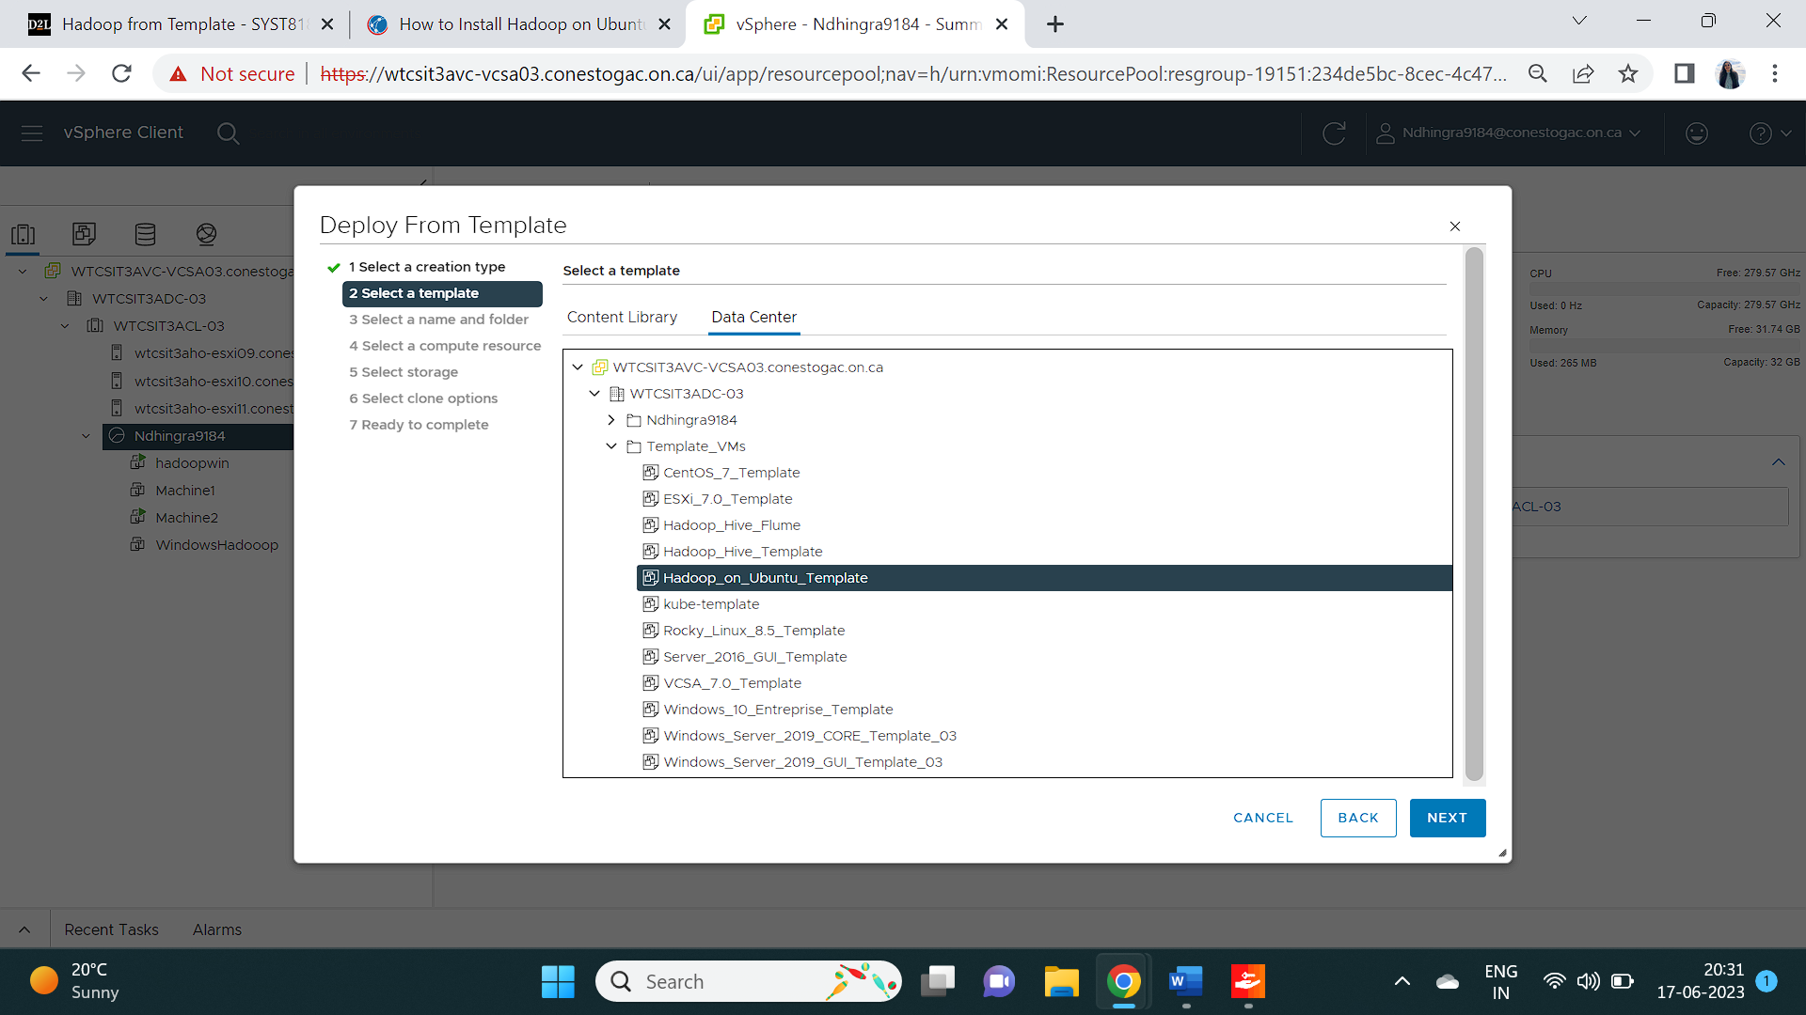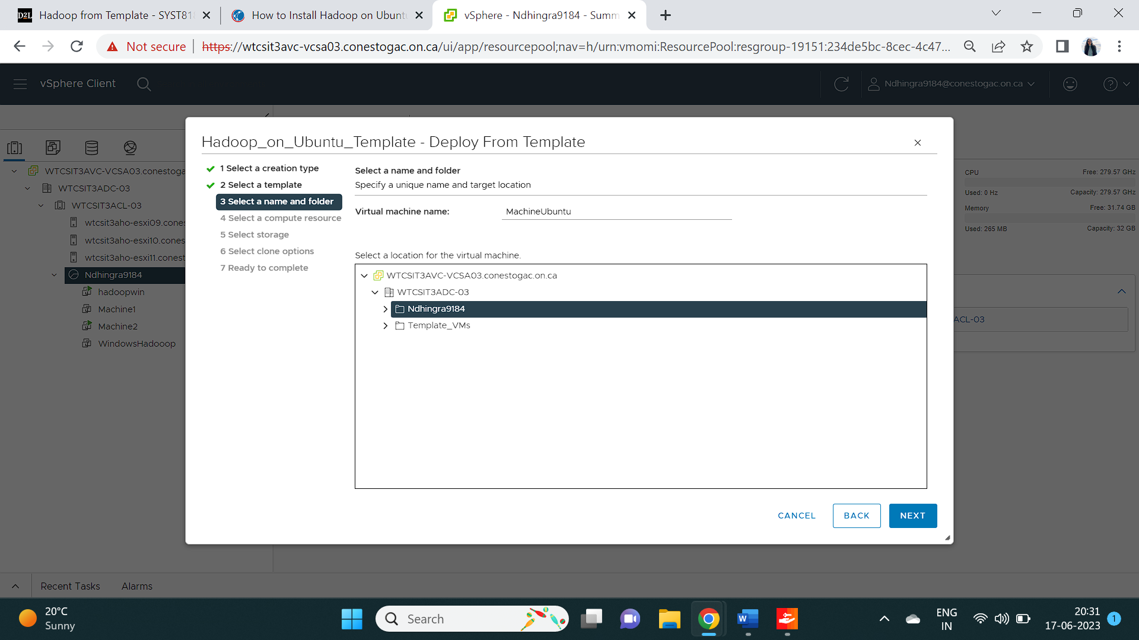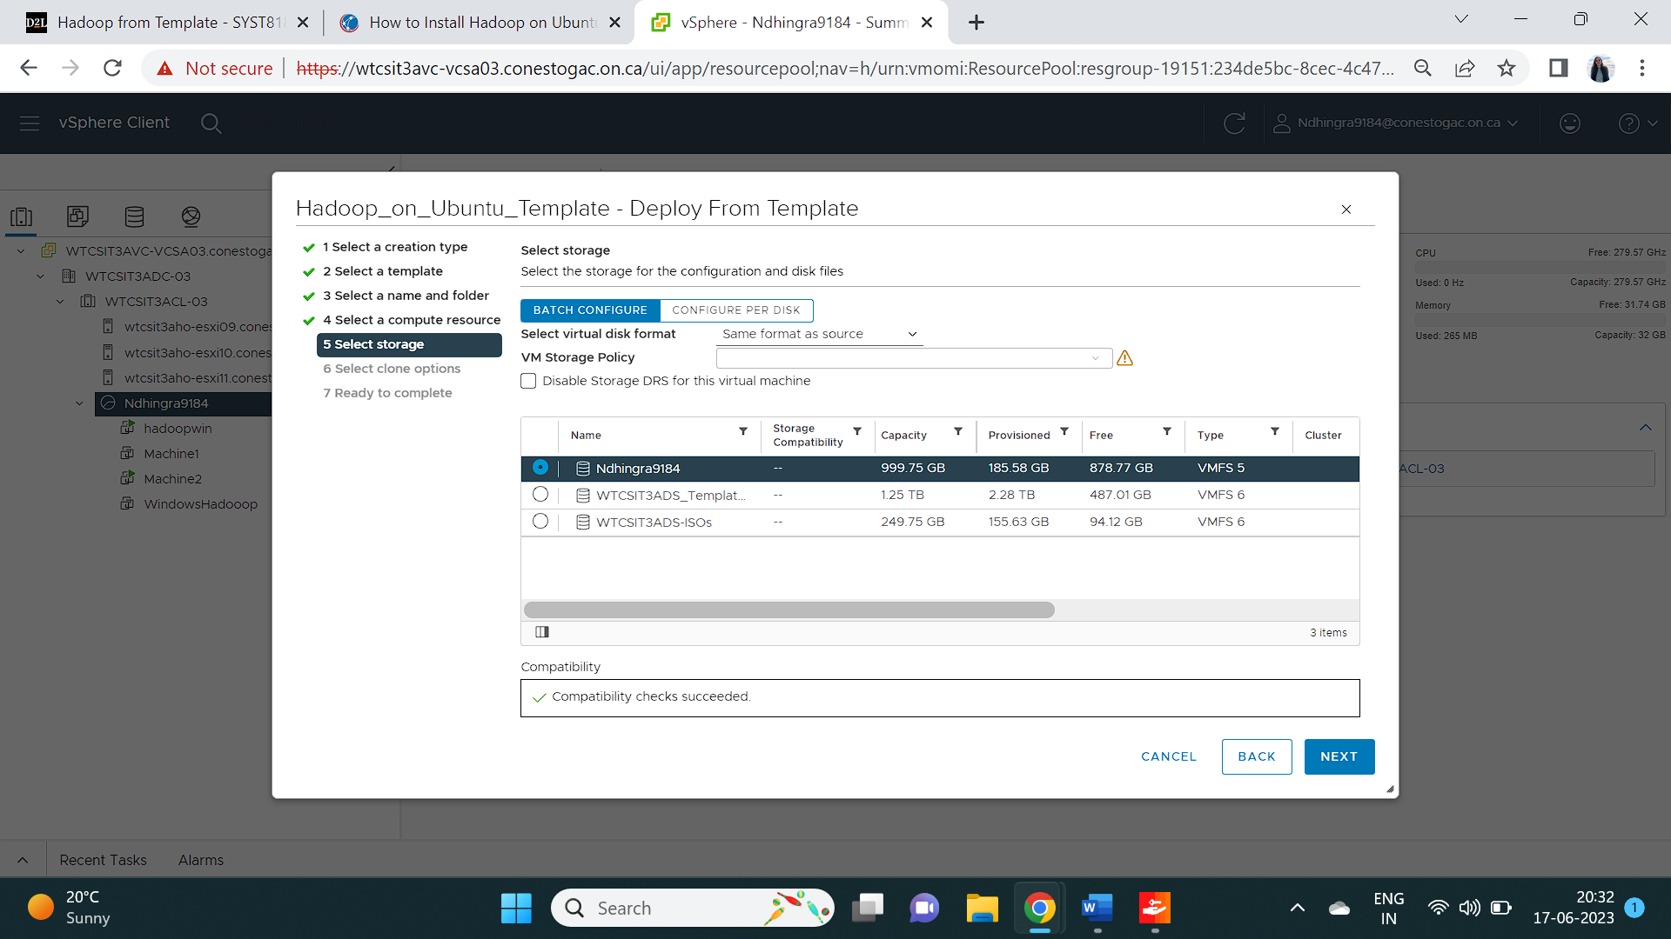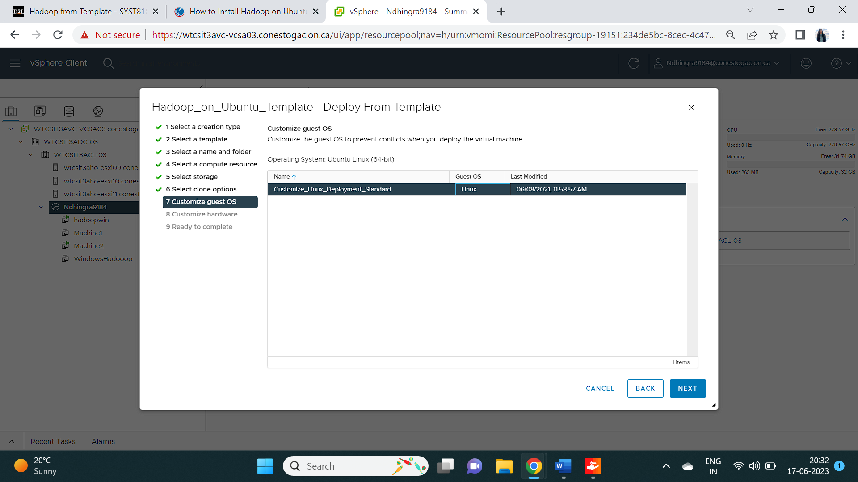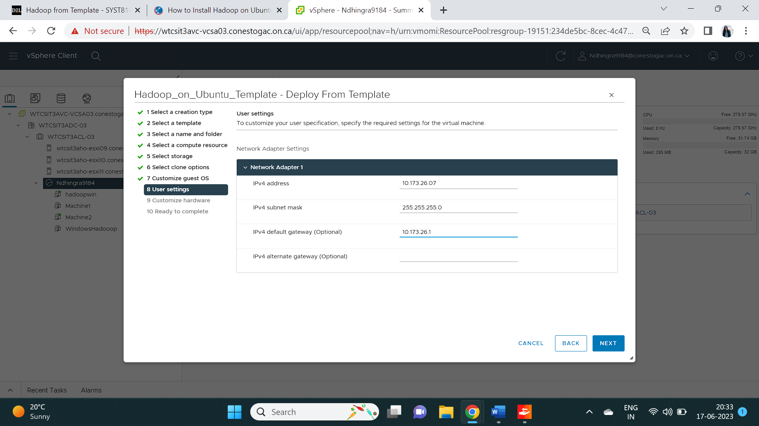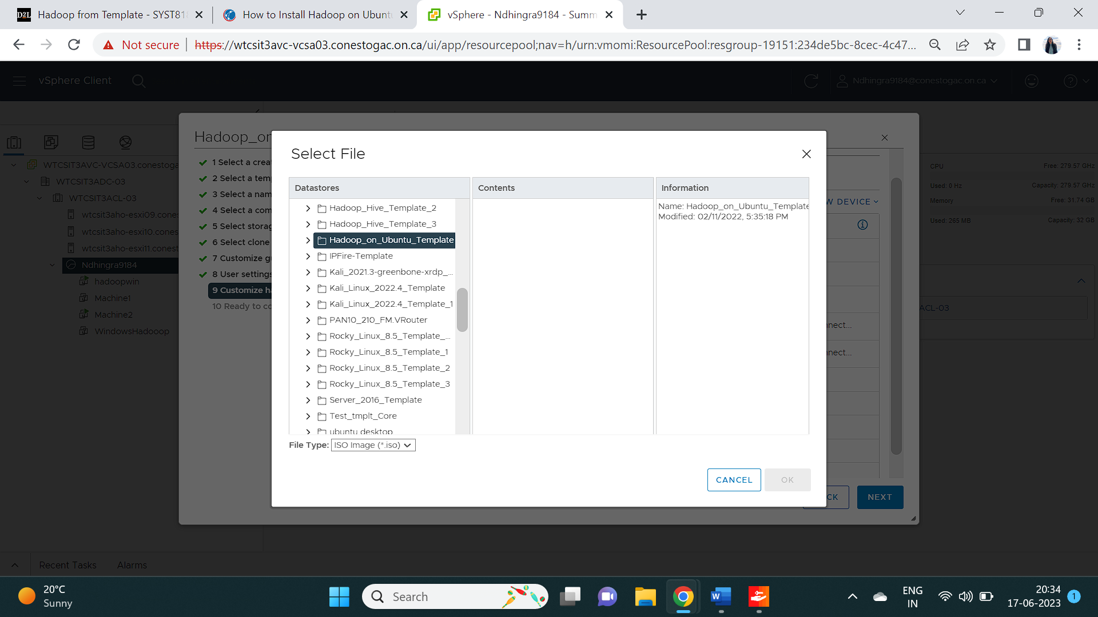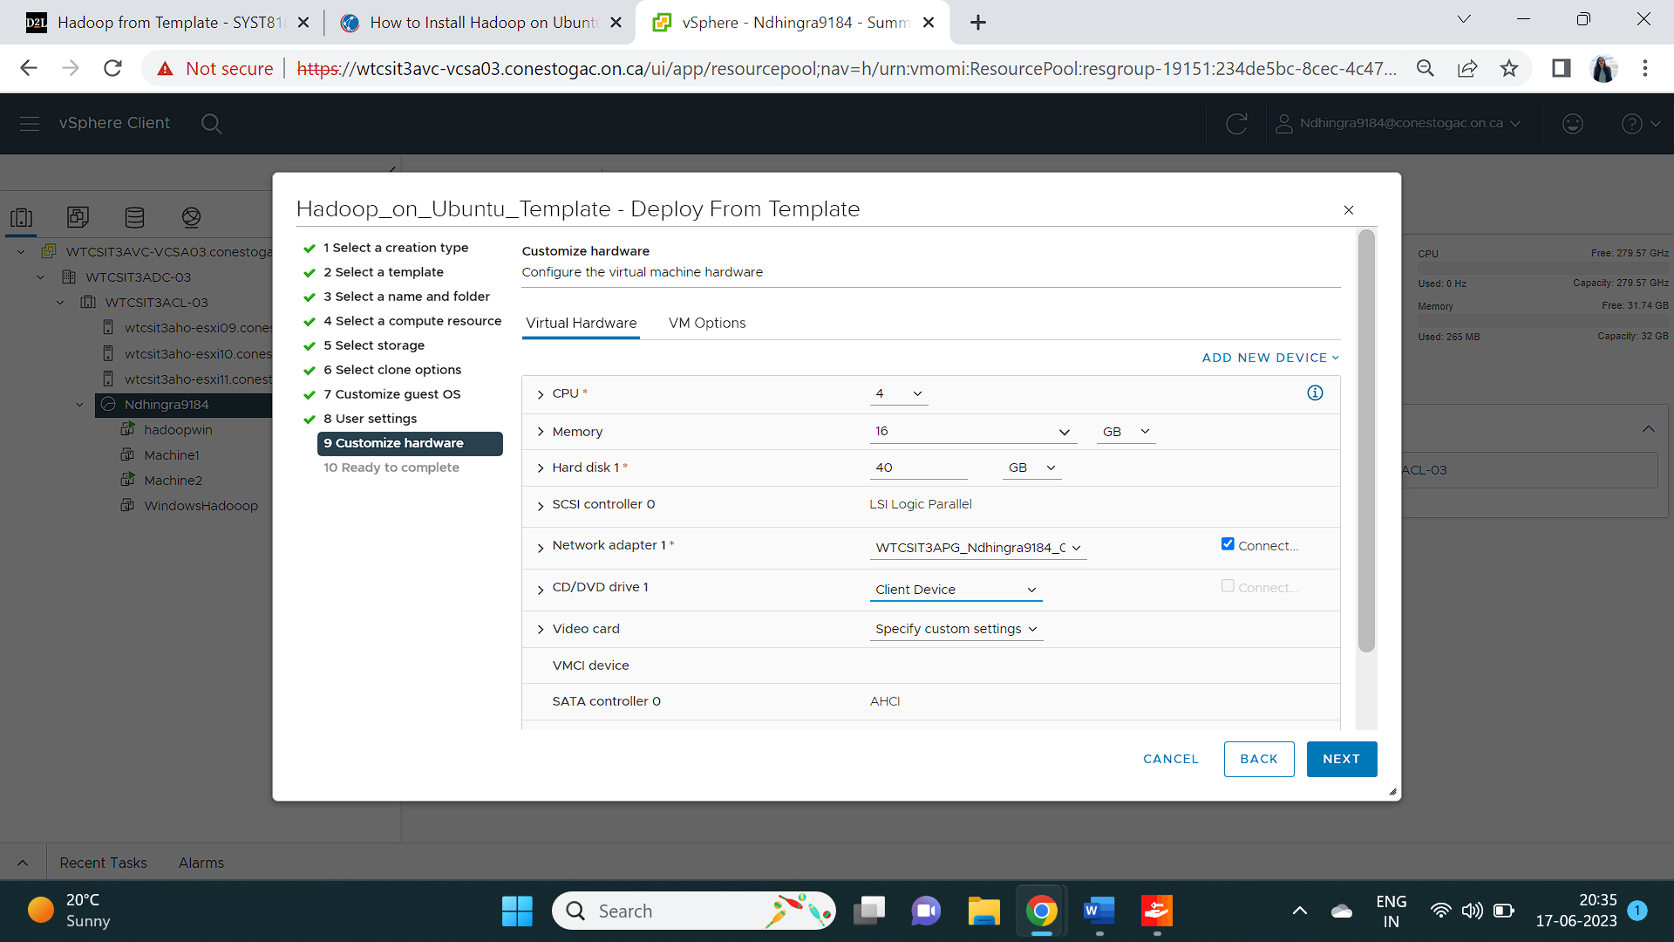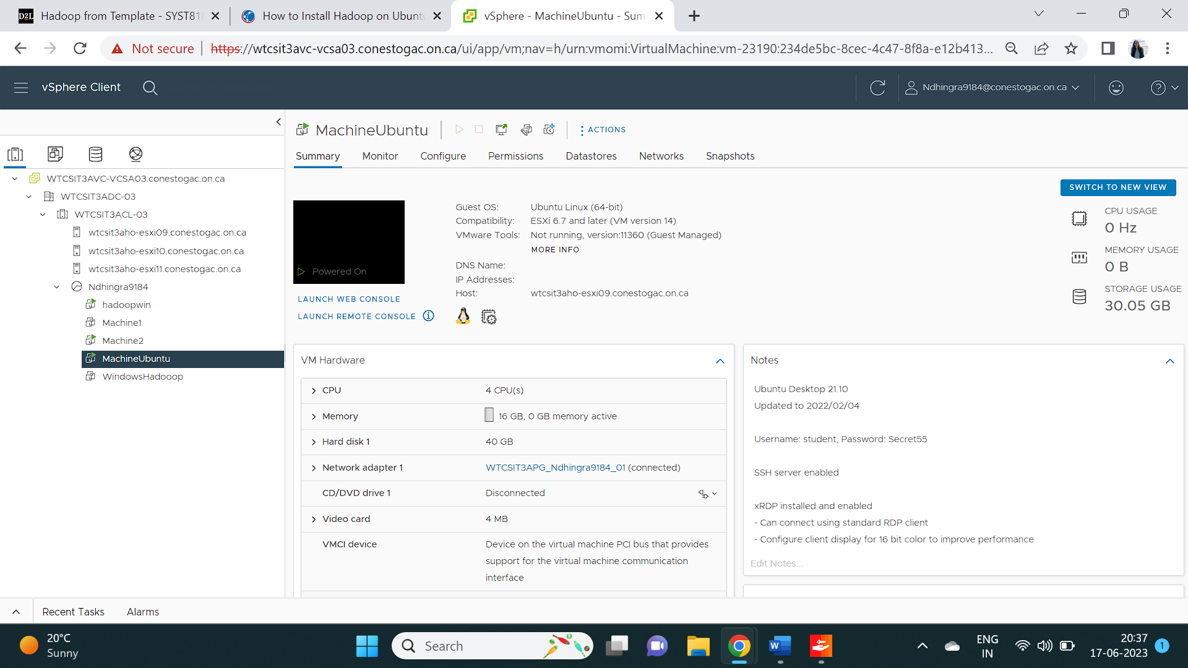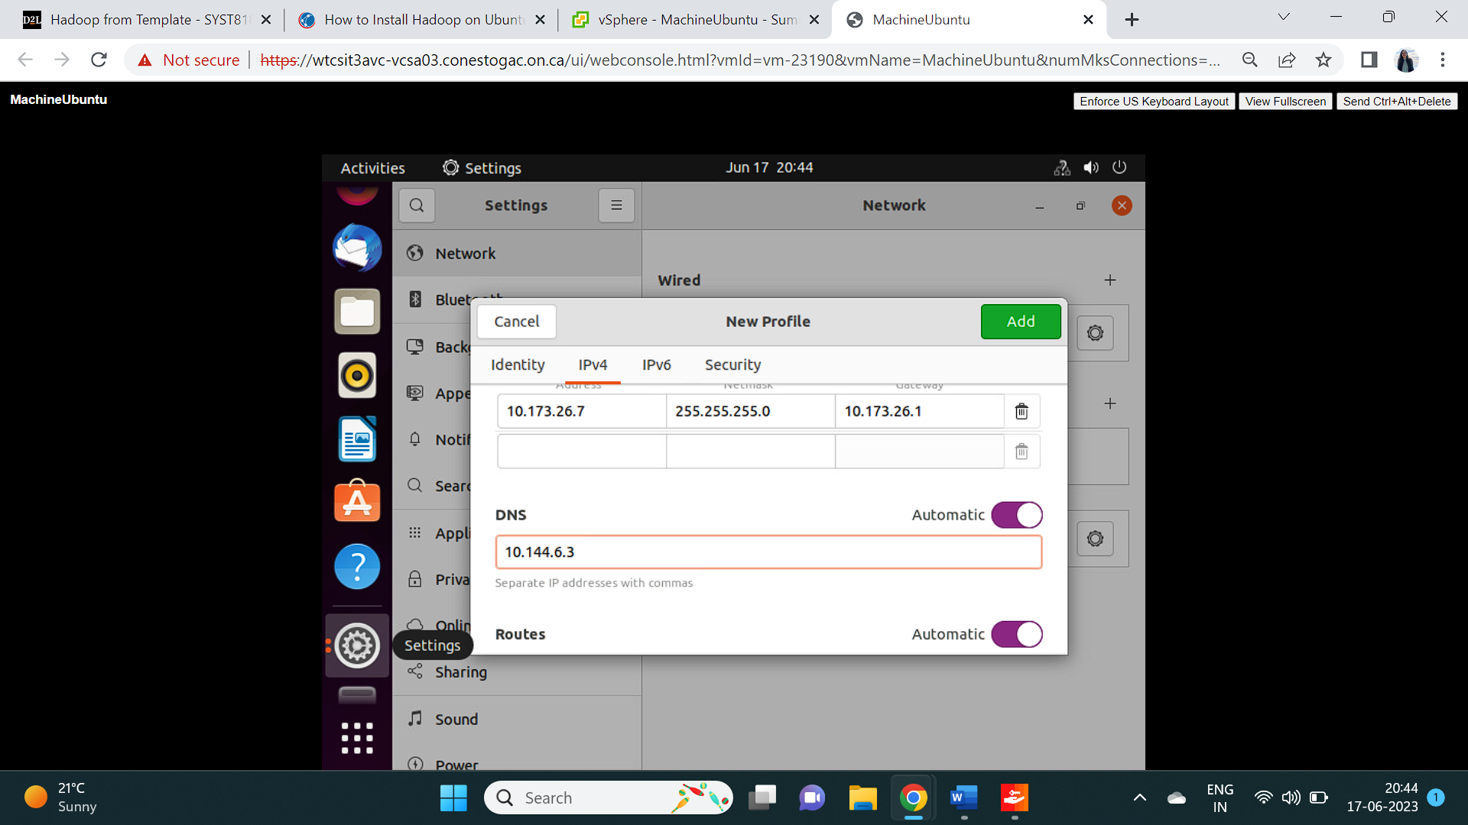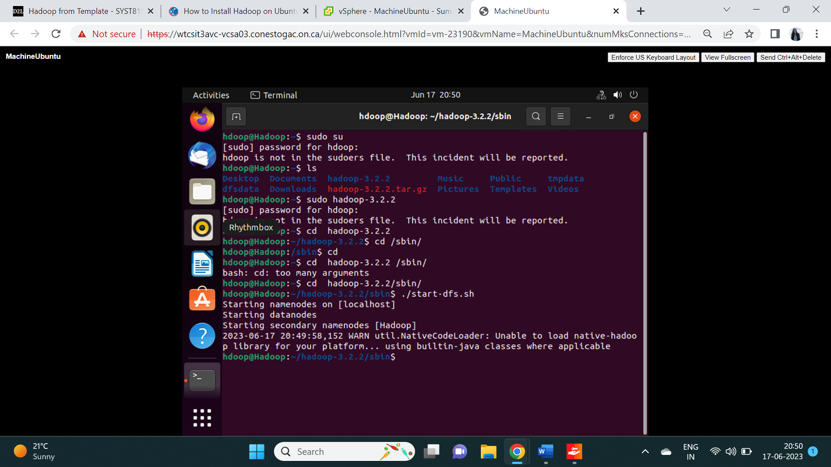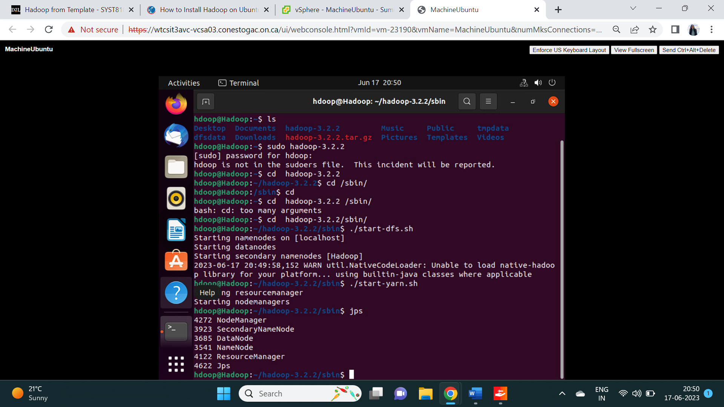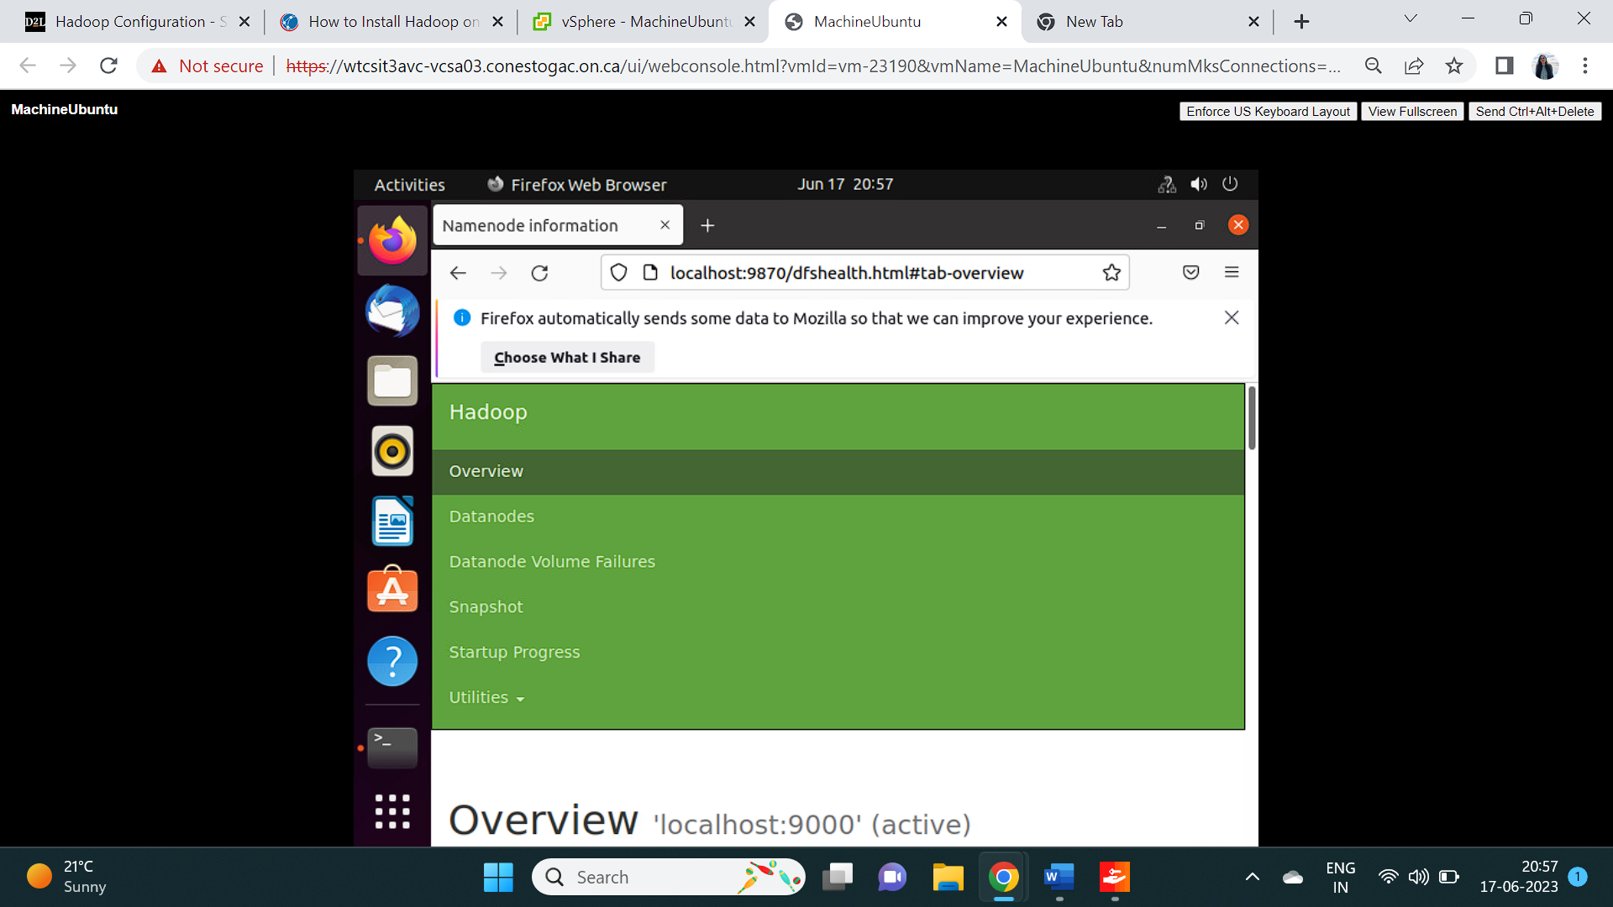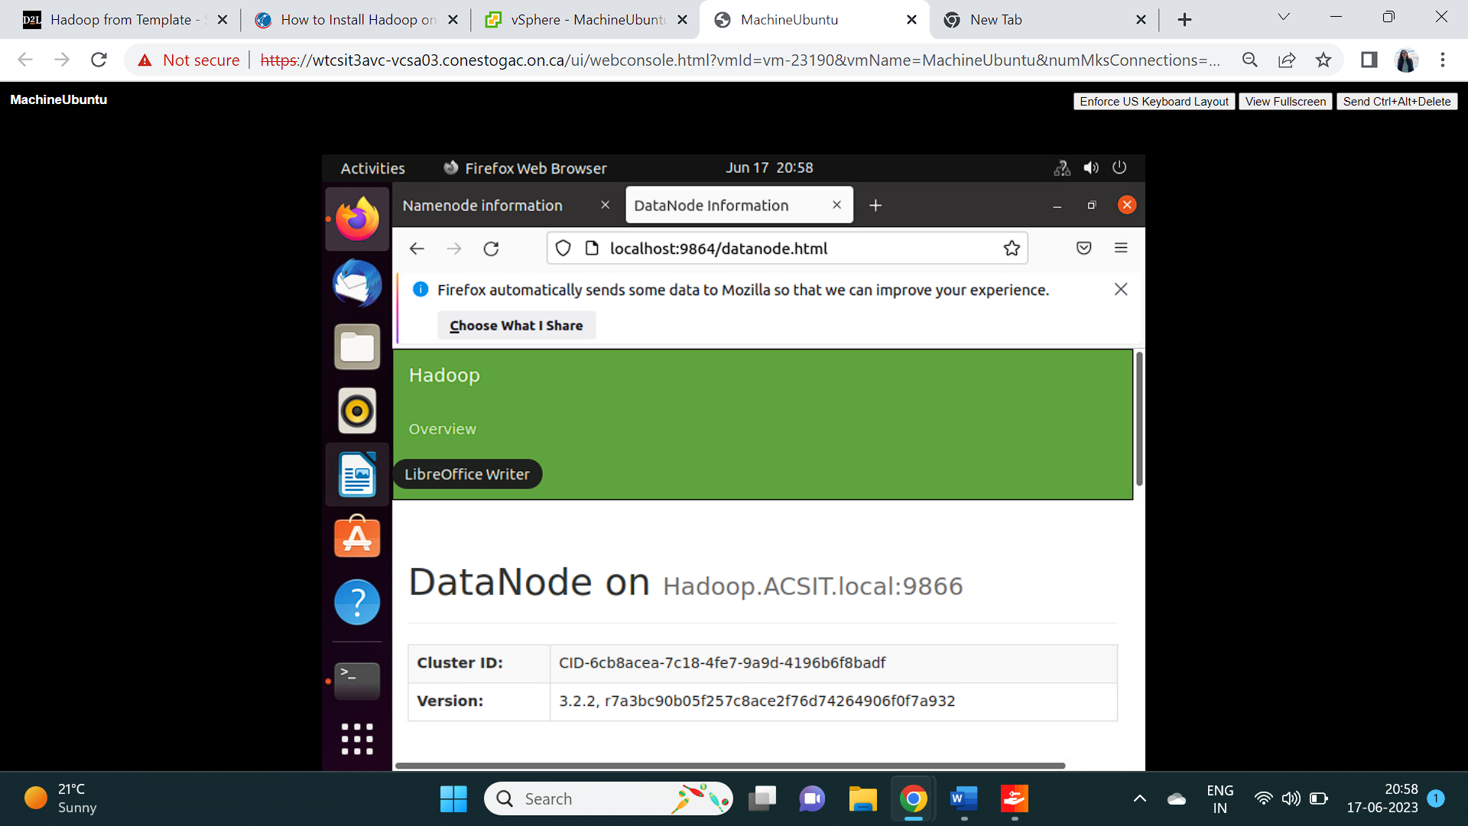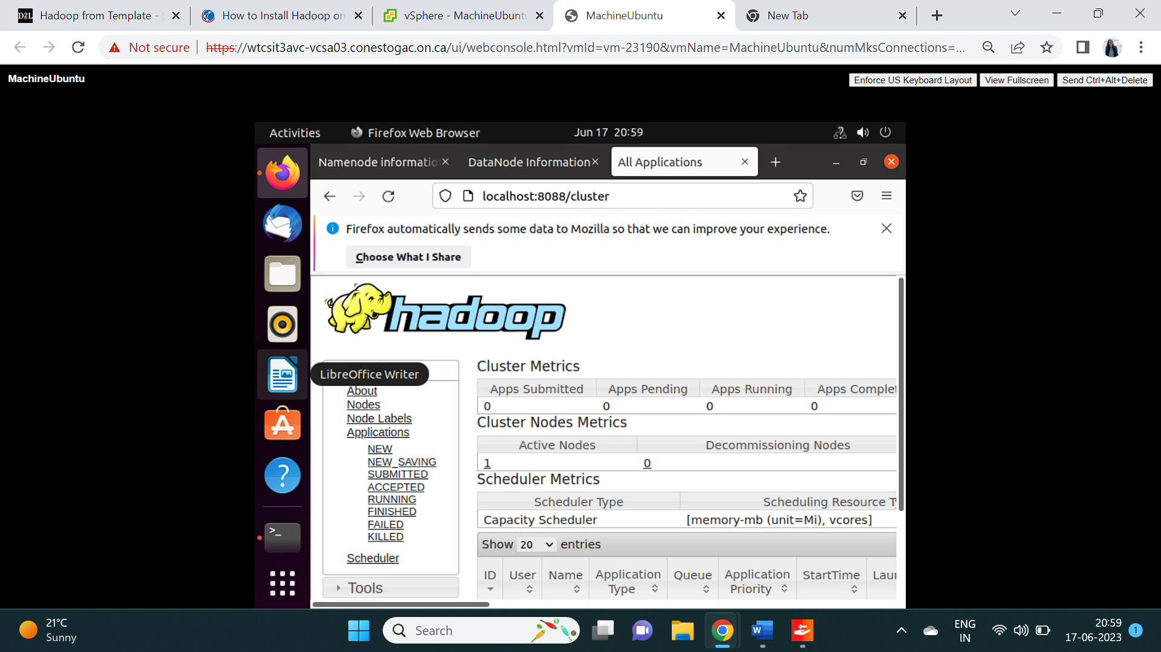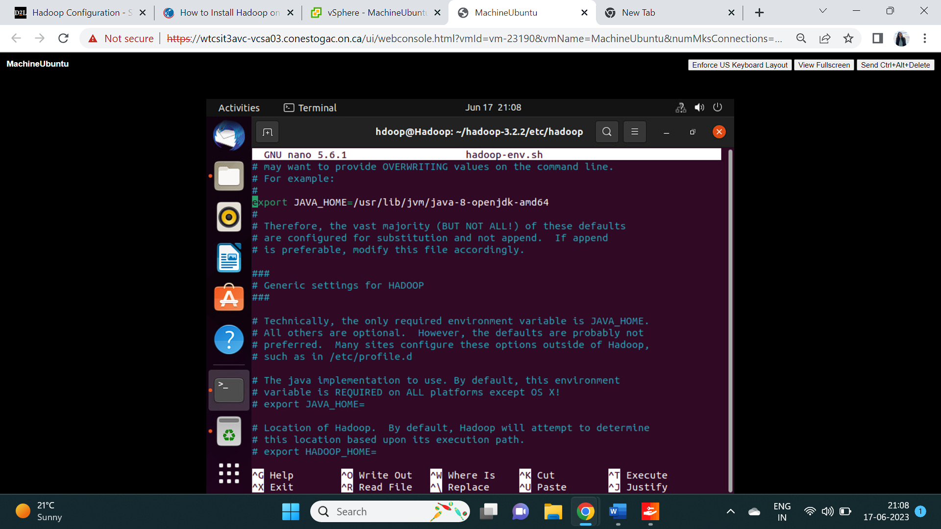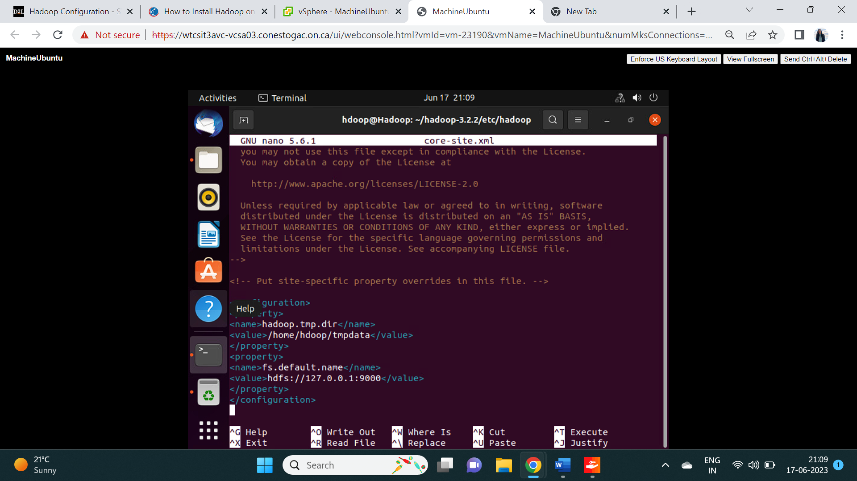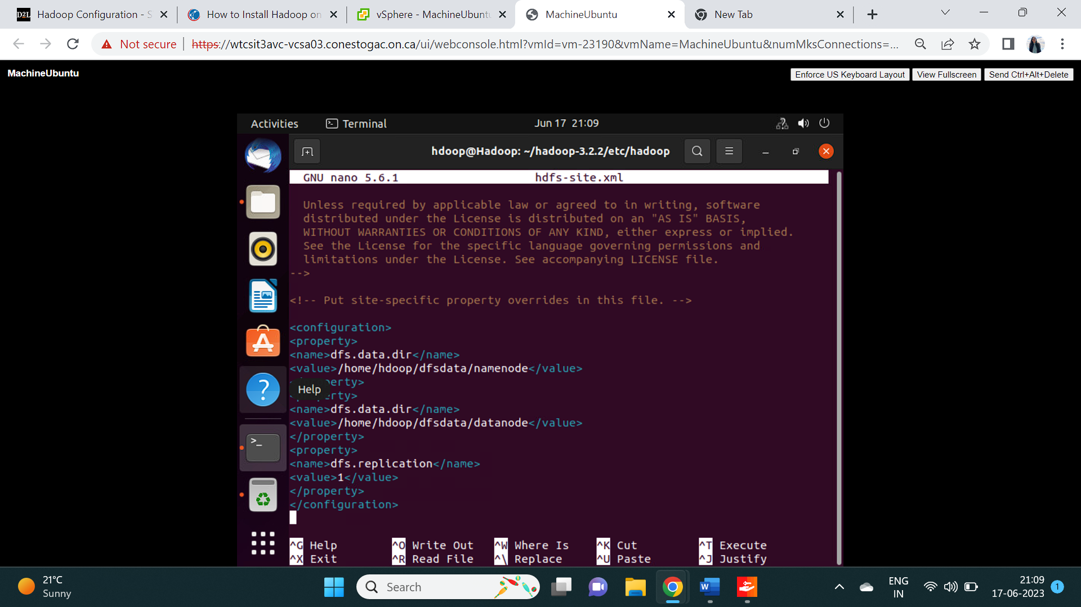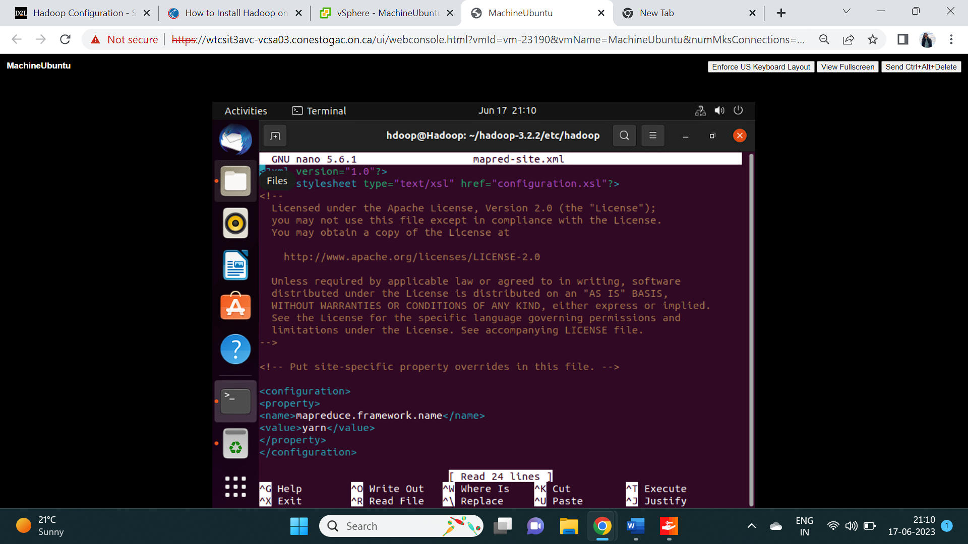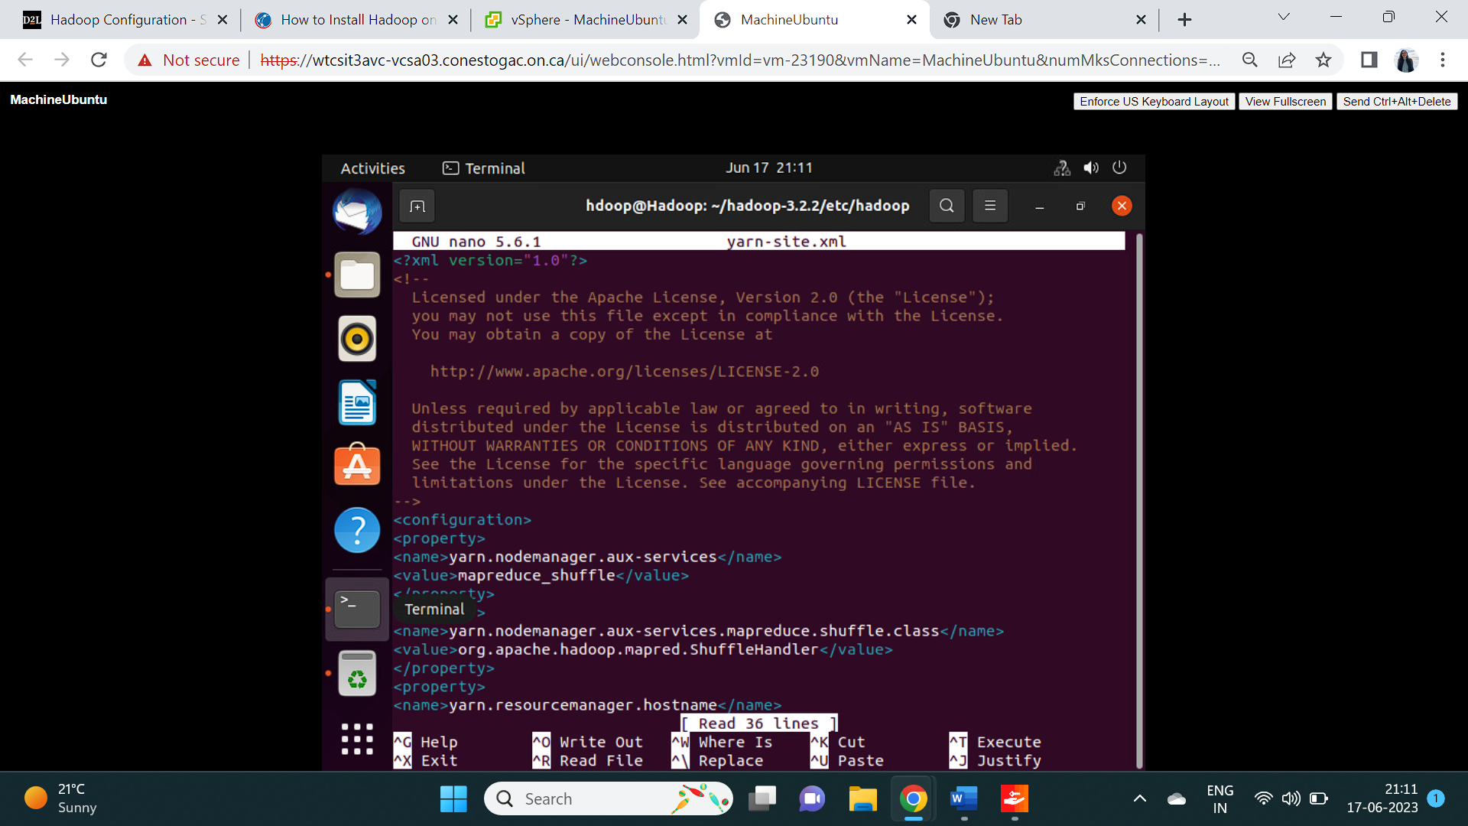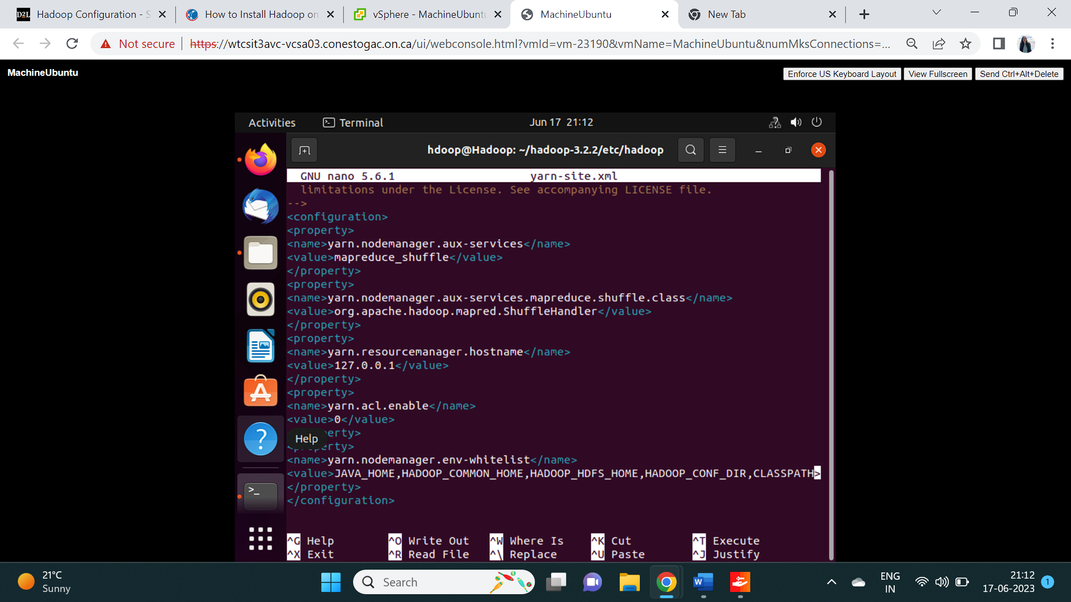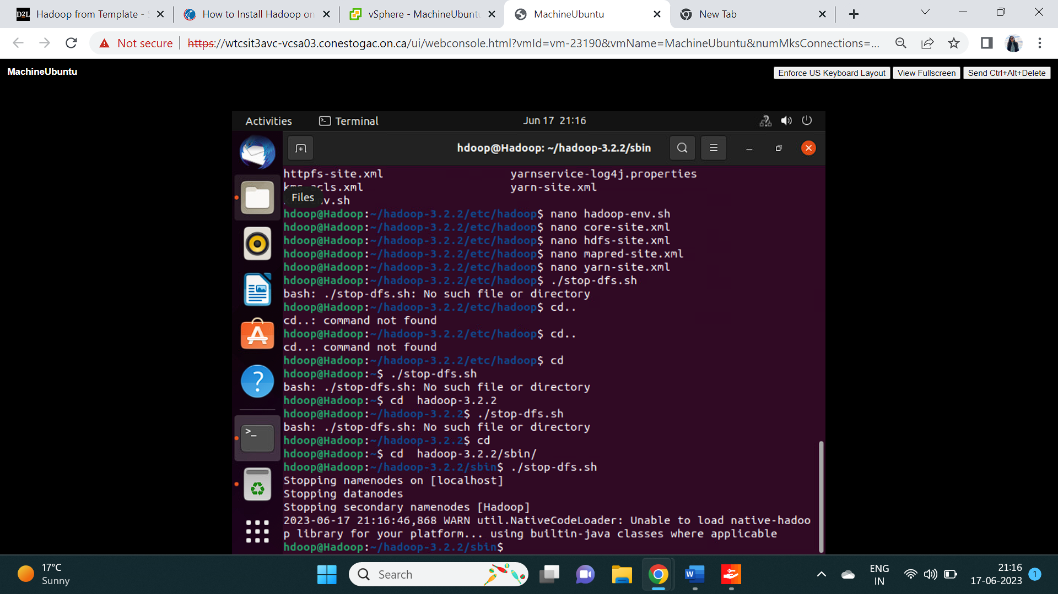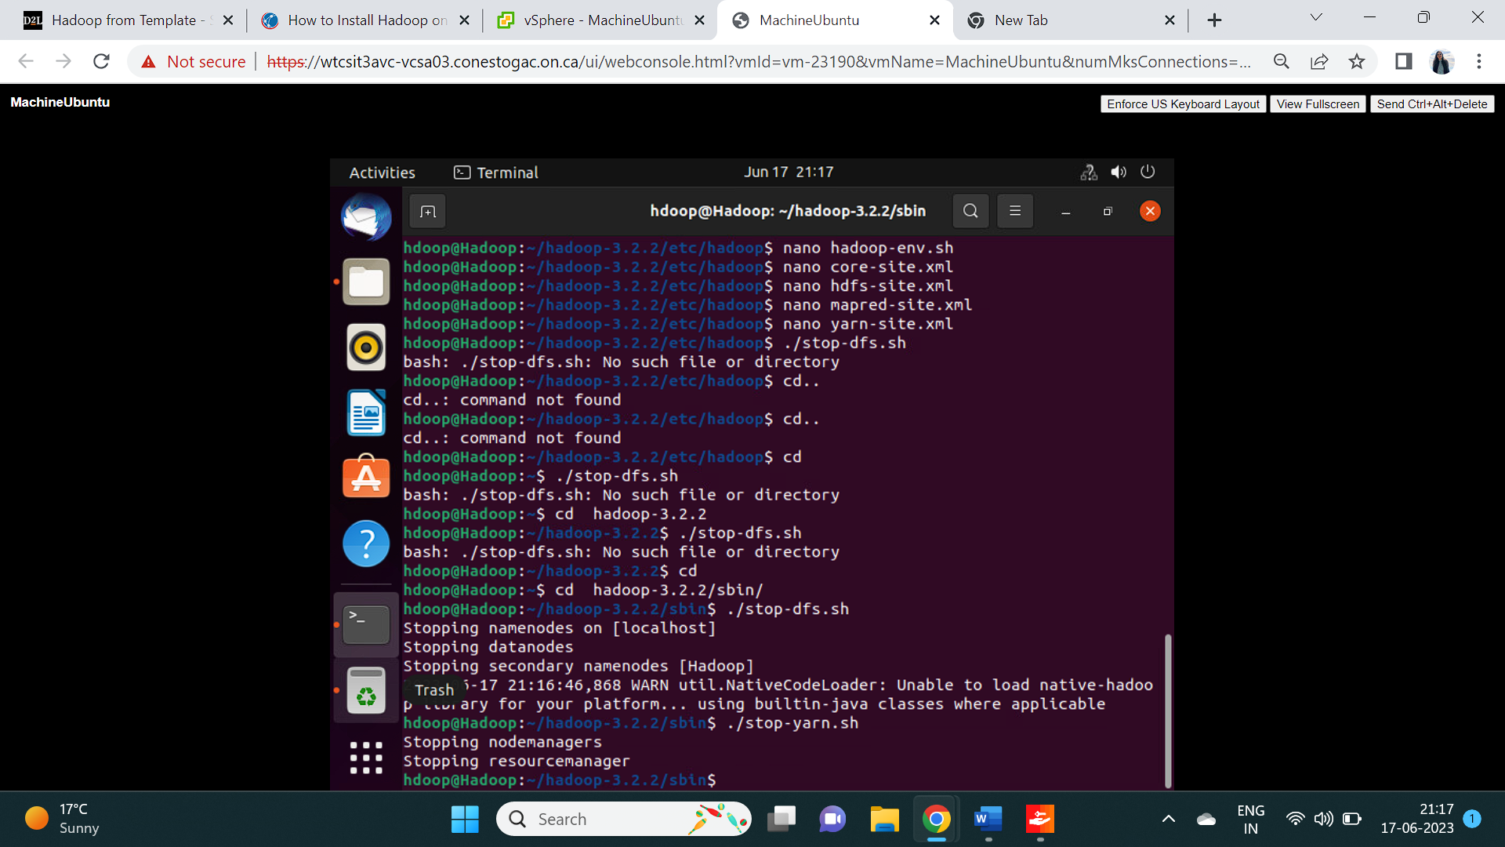

# References

[1] Apache Hadoop (2023) Apache Hadoop

<https://hadoop.apache.org/>

[2] Apache Hadoop (2023) Hadoop: Setting up a Single Node Cluster

<https://hadoop.apache.org/docs/r3.3.5/hadoop-project-dist/hadoop-common/SingleCluster.html>